**Technical reference manual**

This document will provide the technical specifications for every module in the project, regarding the different subjects and specialization areas. The aim is to state every important piece of information to reproduce the project without any doubts.

**PLC**

# System Description

The Automated Control System is a modular system that simulates a process of PLC controlled production. Is integrated by 5 main components: A structure main, One operation panel, one control panel PLC control, a web control panel y one solenoid valve module.

It eases the following studies:

* PLC programming
* Study of Sensors
* Study of Pneumatics and Electropneumatic
* Manufacture process
* Control systems

This manual describes the general operation of the equipment, as well as the components that compose it and its general configuration. This manual is intended to be a general guide for basic operation This manual is not a substitute for the operation manuals for each individual component. The manual has been developed for trained and competent persons, such as engineers, technicians, and programmers.

# Main System Components

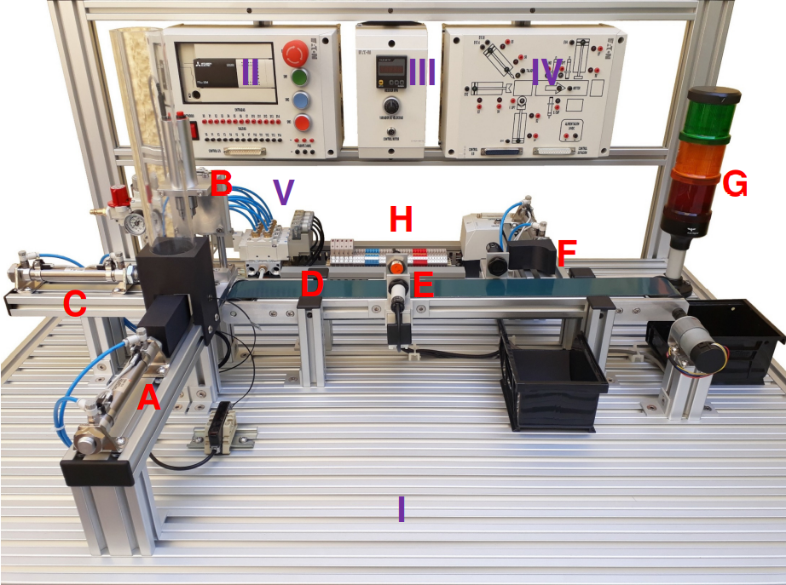

# PRINCIPAL STRUCTURE

## Material Power Unit

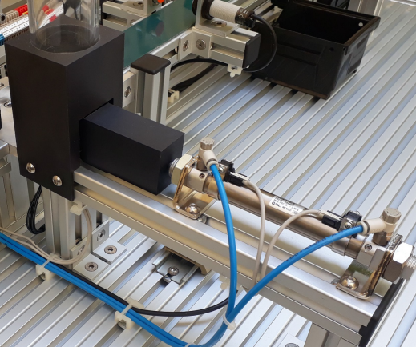Type material feeding unit vertical by gravity for workpieces round 40mm in diameter and 40mm in height and storage capacity of 8 parts.

* A double-acting cylinder with a diameter of 16mm and 75mm stroke with two flow regulators to control the drive speed
* Two reed sensors to detect the cylinder position with led indicator
* A fiber optic sensor for detection presence of material

## Manufacturing Unit

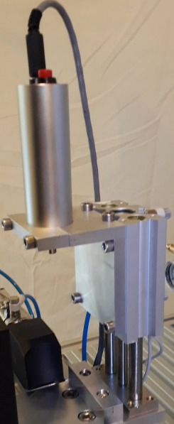

Manufacturing unit through a vertical drill simulation.

* This holds an electric drill of 24 VDC, 15000 rpm, and 30 watts.
* It is a double acting cylinder with double guide, 16mm of diameter, and 2 reed sensors for the position detection with a LED indicator.
* 50mm stroke with two flow regulators to control the drive speed

MGQM16-50 Model

The MGQ series is an air cylinder with guide integrated and two types of guide rod bearing, which can detect the cylinder’s position with built-in magnets for auto switching. It is suitable as stoppers or lifters in conveyors line, depending on which direction you install it. On the table there are some specifications to consider for its use.

This holds an electric drill of 24 VDC, 15000 rpm, and 30 watts. It is a double acting cylinder with double guide, 16mm of diameter, and 2 reed sensors for the position detection with a LED indicator.

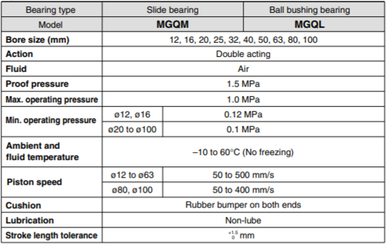

Similar to the previous model, the MGQ operates with compressed air, with a maximum operating pressure of 1.0 MPa and a minimum operating pressure of 0.12 MPa (at ø12 – ø16) or 0.1 MPa (at ø20 – ø100). It has a piston speed range from 50 to 500 mm/s (at ø12 – ø63) and from 50 to 400 mm/s (ø80 – ø100). As cushion, it has a rubber bumper on both ends to prevent damage, and a proof pressure of 1.5 MPa, with an ideal ambient and fluid temperature between -10 to 60°C.

## Loading and transfer unit

Parts loading and transfer unit working towards the conveyor belt. It consists of:

* A double-acting cylinder with a diameter of 16mm and 80mm stroke with two flow regulators to control the drive speed
* Two reed sensors to detect the cylinder position with led indicator

CD85N16-75C-B Model

From the C85 series, it is a double acting single rod, this model has several characteristics that implies a good quality and extended life service, conforming to ISO 6432 and CETOP RP52P.

* It is a high-speed actuation with a low friction and elastomer cushions seals, which enables the pistons speed up to 1500 mm/s.
* All parts are corrosion resistant. End covers and clevis are specially anodized while barrel is stainless steel. Piston rod is stainless steel up to ø16.
* It is designed to function in extremely dusty environments.
* Leak proof assembly, with double swaging of the end covers of the barrel provides an airtight union.
* Simple space-saving design with high dimensional accuracy makes these cylinders very easy to use.
* Rod seal can be quickly replaced, greatly extending the cylinder life.

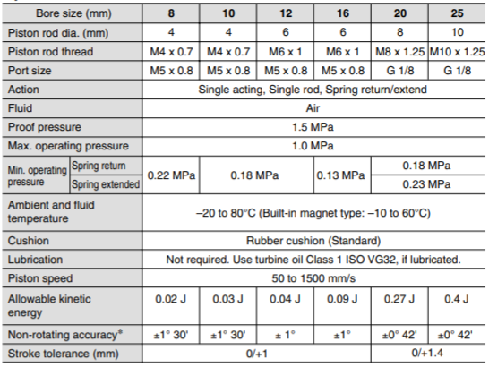As it was mentioned earlier, the fluid to enable the return or extend movement of the actuators is air, therefore, their measurement unit is in pascals (Pa). As we can see in the table, there is a range of operating pressure on which we can use the cylinders. On the maximum value, we can operate with 1.0 MPa, while on the other hand, the minimum pressure depending on the piston rod diameter, is from 0.22 MPa to 0.18 MPa if it is a spring return, and from 0.22 MPa to 0.23 MPa if it is a spring extended. On the piston speed, we also have a range from 50 to 1500 mm/s, where this is dependent to the operating pressure; with a higher pressure, a higher piston speed. As cushion, it has a standard rubber cushion, and a proof pressure of 1.5 MPa, with an ideal temperature range of -20 to 80°C.

## Conveyor Belt

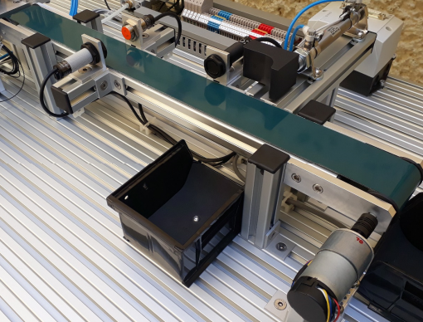A conveyor belt unit for the transportation of the product pieces through the process. Its dimensions are approximately 600 x 60 x 50 mm with a variable speed.

* Double layer green vulcanized endless belt.
* Drive by DC geared motor 12V and 70: 1,150 gear ratio RPM, Torque 14 kg-cm.
* 64-pulse quadrature encoder per revolution

## Inspection Unit

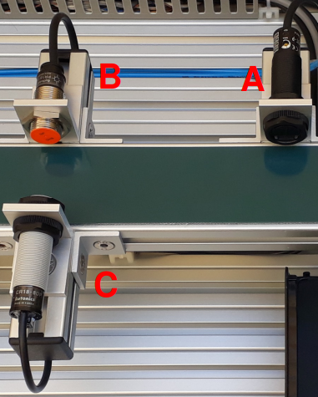Inspection unit to determine the type of workpiece material. It consists of:

1. A diffuse cylindrical type optical sensor of 18mm diameter, feed 12 to 24 VDC, sensing distance 400mm, PNP
2. One 18mm Cylindrical Type Inductive Sensor diameter, supply 12 to 24 VDC, sensing distance 5mm, PNP
3. A cylindrical type capacitive sensor of 18mm diameter, feed 12 to 24 VDC, sensing distance 8mm, PNP

## Expulsion Unit

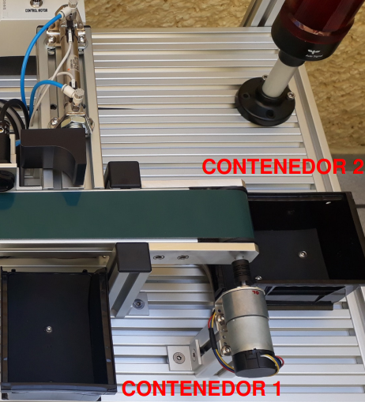Ejector unit for removing parts from work processed to the container finished pieces

* A double-acting cylinder with a diameter of 16mm and 75mm stroke with two flow regulators to control the drive speed
* Two reed sensors to detect the cylinder position with led indicator
* Container 1 of finished pieces of measures 136 x 104 x 76 mm
* Container 2 of finished pieces of measures 136 x 104 x 76 mm

## Signaling Turret

|  |  |
| --- | --- |
| PLC Output | Device Connected |
| X13 | Red light |
| X14 | Orange light |
| X15 | Green light |

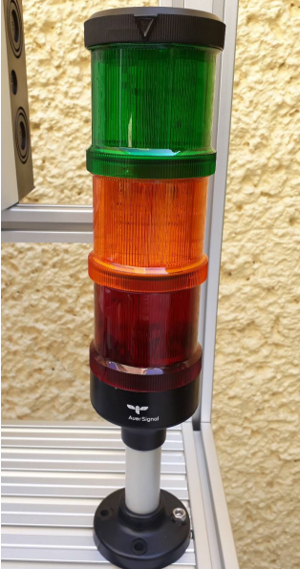Fixed light signaling tower in 3 colors: green, orange and red. 24VDC power supply. The terminals are pre-wired to the outputs of the PLC using the "Control I / O" cable and connector of the PLC Control Panel and the Control Panel Operation and is only operable when connect the system using flat cables 37-pin

## Connection Unit

Connection unit that concentrates the sensor terminals, solenoid valves, signaling turret and belt motor conveyor to connect to the Control Panel Flat cable and connector operation 37 pins [STATION CONTROL] and to the Band control by round connector and 6-pin cable [MOTOR CONTROL]

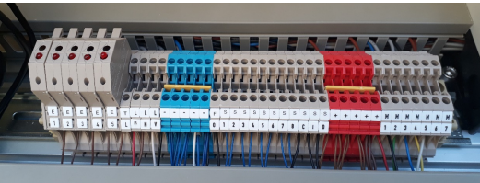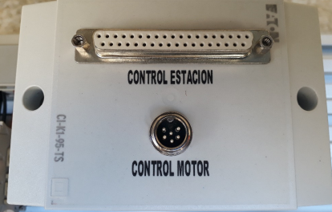

# PLC CONTROL PANNEL

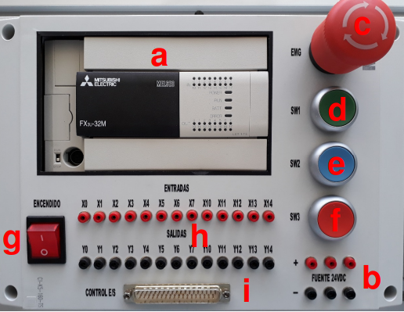Panel mounted on the frame of the structure main containing the Logic Controller FX brand programmable (PLC) family Mitsubishi. All inputs and outputs of the PLC are available with 2mm terminals for individual operation of components and additionally they are available in a connector and flat 37-pin cable for direct connection to the Operation Panel.

It consists of:

1. One 16-input FX3U-32MR / DS PLC 24VDC digital and 16 relay outputs
2. A 24VDC 2A power supply
3. An emergency stop button [EMG]
4. A green push button NO pre-wired to the digital input X15 of the PLC [SW1]
5. A blue push button NO pre-wired to the PLC digital input X16 [SW2]
6. A red NC pushbutton prewired to the PLC digital input X17 [SW3]
7. A power switch with light indicator
8. 2mm terminals for inputs and outputs i. 37-pin [I / O CONTROL] connector

FX3U-32MR/DS

Mitsubishi PLC with 16 configurable direct current digital inputs SINK (NPN) or SOURCE (PNP), 16 8A relay outputs. DIN rail mount type, Program capacity: 64,000 steps, Programming language: Ladder, List of instructions and SF. 24VDC power supply. Interchangeable communication expansion cards that install directly into the unit principal. Integrated real time clock. Basic instructions: 0.065 µs / instruction (instruction of Contact). Applied instructions: 0.642 µs / instruction (MOV instruction)

1. 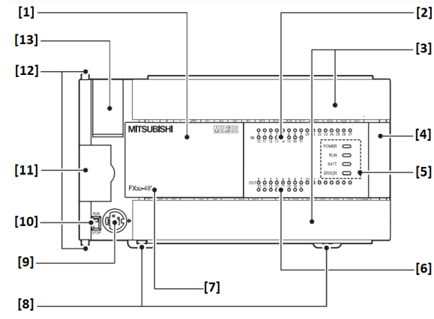Cover
2. Status indication of the inputs
3. Connection terminal cover
4. Extension connection cover
5. LED indication
6. Status indication of the outputs
7. Base unit type
8. Mounting tab for DIN rail
9. Programming units interface
10. RUN / STOP switch
11. Adapter slot cover
12. Interlock for adapter module
13. Battery compartment cover
14. 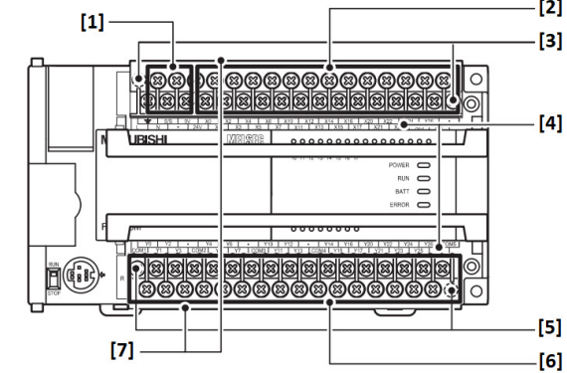Connections for supply voltage
15. Input connections
16. Fastening screws for the terminal block higher
17. Designation of the connections
18. Fastening screws for the terminal block lower
19. Output connections
20. Contact protection

Input and output configuration

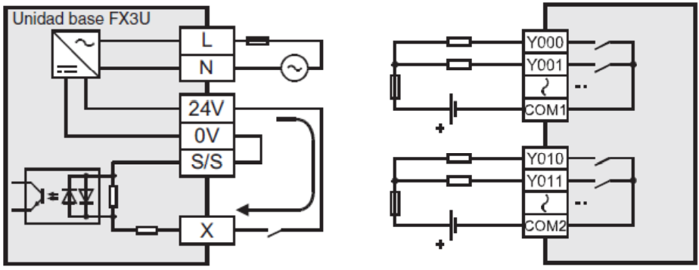

Input assignment table for the 37-pin [I / O CONTROL] connector

|  |  |
| --- | --- |
| PLC Inputs | Device Connected |
| X0 | Optical fiber sensor [F. OPT] |
| X1 | Feed Unit Piston Reed Sensor “Retracted” [S1] |
| X2 | Feed Unit Piston Reed Sensor “Extended” [S2] |
| X3 | Reed Sensor Charge and Transfer Unit Piston "Retracted" [S3] |
| X4 | Reed Sensor Charge and Transfer Unit Piston "Extended" [S4] |
| X5 | Reed Sensor Manufacturing Unit Piston "Retracted" [S5] |
| X6 | "Extended" Manufacturing Unit Piston reed sensor [S6] |
| X7 | Reed Sensor Eject Unit Piston "Retracted" [S7] |
| X10 | Ejection Unit Piston reed sensor “Extended” [S8] |
| X11 | Capacitive Sensor [S. CHAP] |
| X12 | Inductive sensor [S. IND] |
| X13 | Optical Sensor [S. OPT] |
| X14 | Not assigned |
| X15 | Green Button NA [SW1] |
| X16 | Blue Button NA [SW2] |
| X17 | Red NC button [SW3] |

Output assignment table for the 37-pin [I / O CONTROL] connector

|  |  |
| --- | --- |
| PLC Outputs | Device Connected |
| Y0 | Power Unit Solenoid Valve [EV1] |
| Y1 | Charge and Transfer Unit Solenoid Valve [EV2] |
| Y2 | Manufacturing Unit Solenoid Valve Position A [EV3 A] |
| Y3 | Manufacturing Unit Solenoid Valve Position B [EV3 B] |
| Y4 | Ejection Unit Solenoid Valve [EV4] |
| Y5 | Drill |
| Y6 | Conveyor Belt |
| Y7 | Not assigned |
| Y10 | Not assigned |
| Y11 | Not assigned |
| Y12 | Not assigned |
| Y13 | Not assigned |
| Y14 | Not assigned |
| Y15 | Red Signal Turret Lamp |
| Y16 | Orange Signal Turret Lamp |
| Y17 | Green Signal Turret Lamp |

Main Operating Monitors

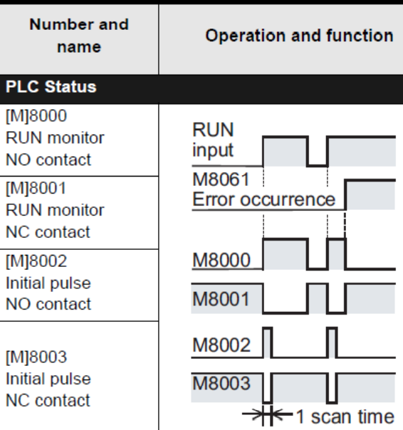

# BELT CONTROL PANEL

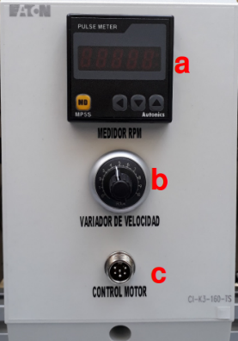

Panel mounted on the frame of the structure main containing speed control of the conveyor belt motor, with a integrated 12VDC source.

1. An engine rev meter
2. One controller and speed knob band motor
3. One 6-pin [CONTROL MOTOR] for connection to the connection in the main structure

# OPERATION PANEL

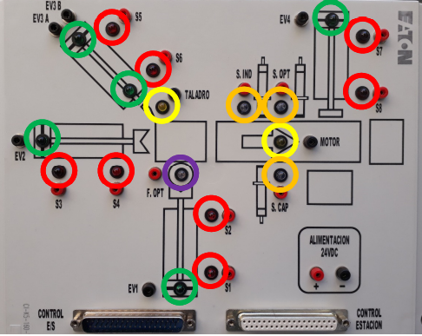Panel mounted on the frame of the structure main with led indicators to display the status of the components from the main structure through the connector and 37-pin flat cable. Inputs and outputs of the components of the main structure They are available in 2mm terminals for individual operation of components and additionally allows wireless programming practices using the flat cable and connector 37-pin to establish communication between the operation panel and the control panel from the PLC.

It consists of:

1. 8 LED indicators in red color of the reed sensors of each cylinder of the system [S1… S8]
2. 2 Yellow LED indicators for the belt motor operating status conveyor and drill [MOTOR, DRILL]
3. 3 Orange LED indicators for the sensors of the inspection unit [S. CAP, S. IND, S. OPT]
4. 5 LED indicators in green color for the operating status of the solenoid valves [EV1, EV2, EV3 A, EV3 B, EV4]
5. 1 LED indicator in violet color for the fiber optic sensor
6. 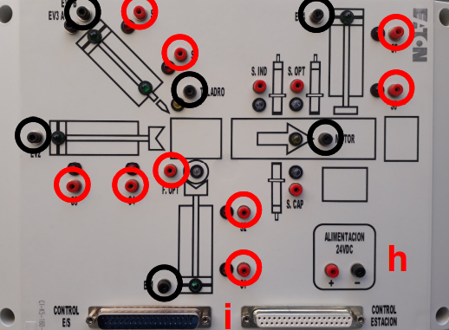2mm **black** terminals for the signals from the Solenoid Valves, Motor and Drill coming from the structure principal
7. 2mm red terminals for the sensor signals from the Principal structure
8. Terminals for power supply input 24VDC when the power cord is not used CONTROL I / O connector
9. 2 37-pin connectors for connection Directly with the PLC Control Panel [I / O CONTROL] and Main Structure [STATION CONTROL]

# ELECTRO VALVE MODULE

Direct mounted on the table of the main structure that connections are wired to Unit of connection.

1. 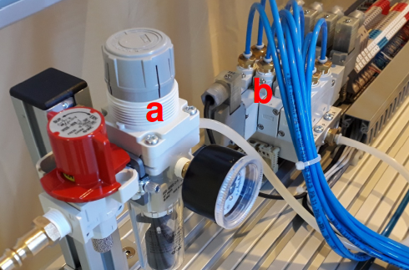A maintenance unit (Filter + Regulator) and shut-off valve
2. A block of 4 electro valves positions with a bistable solenoid valve and three single solenoid valves with quick connectors for 4mm hose diameter and 24VDC coils with led indicator of operation and a maximum operating pressure of 10 Pub.

# System Power Up Procedure

1. Review and follow the safety recommendations in section 1 of this manual
2. Connect the equipment to the electrical supply
3. Connect the 6-pin cable to the MOTOR CONTROL ports on the Engine Control Panel. Band and Main Structure Connection Unit
4. Connect the 37-pin male-male flat cable to the STATION CONTROL ports of the Operation Panel and Main Structure Connection Unit

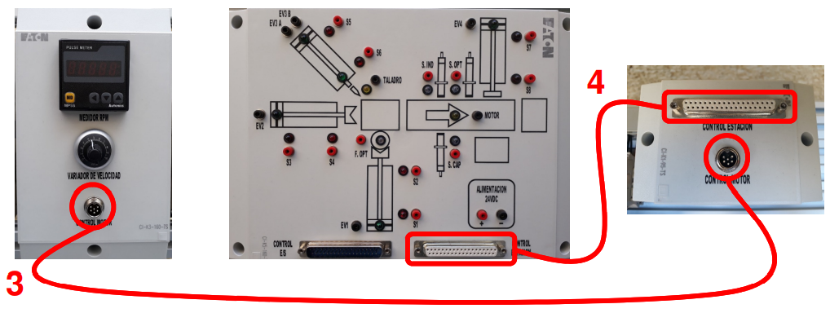

1. 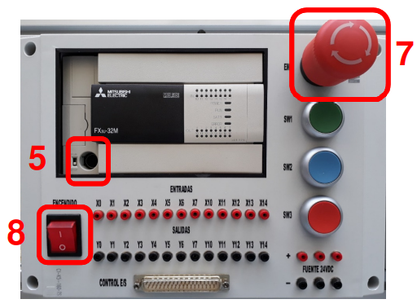Connect the programming cable to the PLC port and PC if downloading any program to PLC
2. Make the desired connections between the PLC Control Panel and the Control Panel. Operation
3. Disable the emergency stop in the PLC Control Panel
4. Turn on the main switch of the PLC Control Panel. The switch indicator light

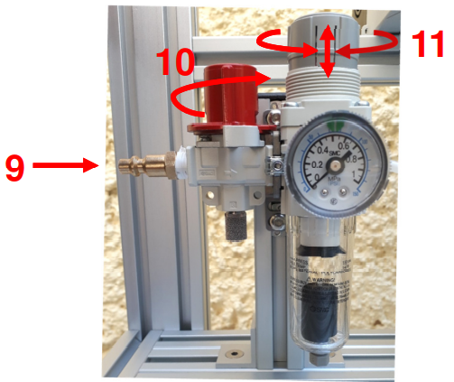

1. Connect the air line to the maintenance unit
2. Close the shut-off valve
3. Adjust the air pressure to the green indicator mark on the pressure gauge. Lift the knob to unlock the regulator and turn the regulator to increase or decrease the pressure of job. Lower the knob to re-lock the regulator when you have adjusted the pressure

# Configurations of Point to Point Connections

* To connect the sensors of the Operation Panel, connect each of the terminals colored red [S1… S8, F. OPT, S. CAP, S. IND, S. OPT] exclusively to the red terminals of the inputs of the PLC Control Panel [X0… X14]
* For the connection of the actuators of the Operation Panel, connect each of the black terminals [EV1, EV2, EV3 A, EV3 B, EV4, MOTOR, DRILL] exclusively to the black terminals of the PLC Control Panel outputs [Y0… Y14]

**REMEMBER TO TURN OFF THE MAIN SWITCH EVERY TIME YOU PERFORM OR MODIFY SOME CONNECTIONS**

**WARNING**

**DO NOT DIRECTLY CONNECT THE 24VDC POWER OUTPUT TO THE RED TERMINALS OF THE SENSORS ON THE OPERATION PANEL AS IT COULD PERMANENTLY DAMAGE THE LED INDICATORS AS WELL AS THE SENSORS**

**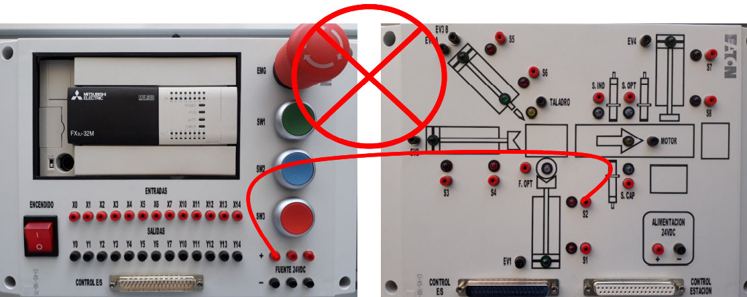**

**WARNING**

**DO NOT CONNECT THE PLC OUTPUTS TO THE RED TERMINALS OF THE SENSORS IN THE OPERATION PANEL AS IT COULD DAMAGE THE LED INDICATORS AS WELL AS THE SENSORS**

**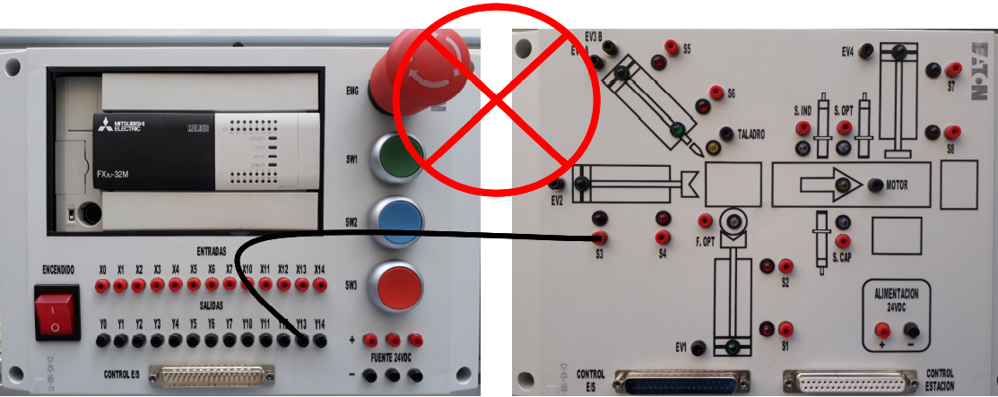**

Connection example of the Material Feeding Unit

|  |  |
| --- | --- |
| INPUTS > SENSORS | OUTPUTS > ACTUATORS |
| X0 > F. OPT | Y0 > EV1 |
| X1 > S1 |  |
| X2 > S2 |  |

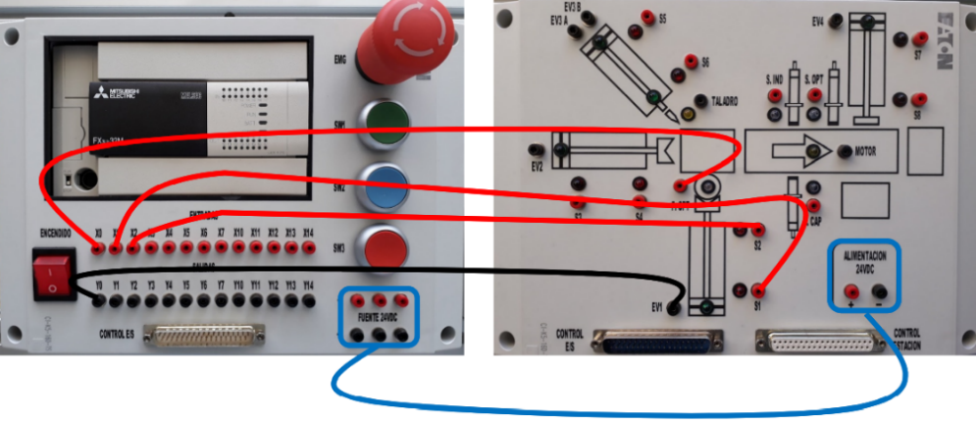

Connection example of the Loading and Transfer Unit

|  |  |
| --- | --- |
| INPUTS > SENSORS | OUTPUTS > ACTUATORS |
| X3 > S3 | Y1 > EV2 |
| X4 > S4 |  |

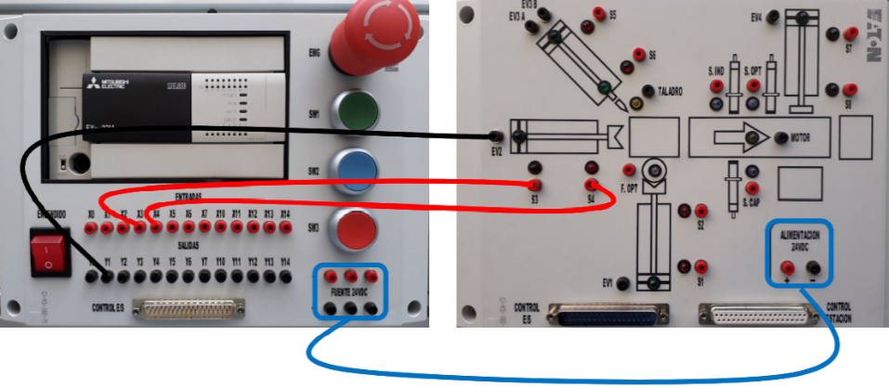

Manufacturing Unit connection example

|  |  |
| --- | --- |
| INPUTS > SENSORS | OUTPUTS > ACTUATORS |
| X5 > S5 | Y2 > EV3 A |
| X6 > S6 | Y3 > EV3 B |
|  | Y5 > DRILL |

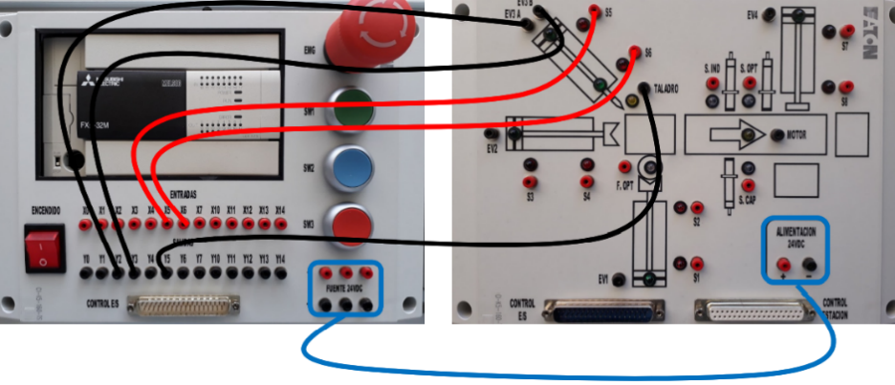

Conveyor Belt Unit Connection Example

|  |  |
| --- | --- |
| INPUTS > SENSORS | OUTPUTS > ACTUATORS |
|  | Y6 > MOTOR |

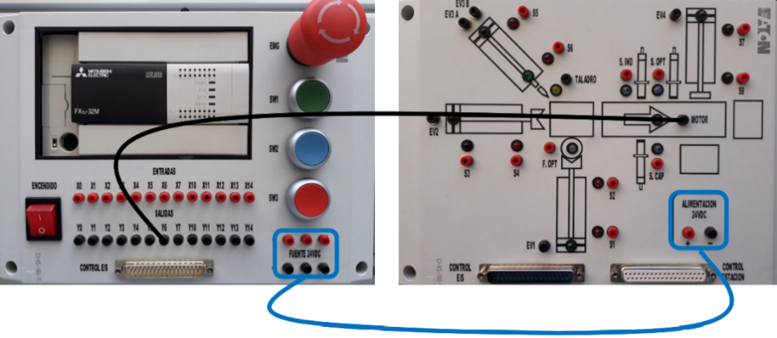

Inspection Unit Connection Example

|  |  |
| --- | --- |
| INPUTS > SENSORS | OUTPUTS > ACTUATORS |
| X11 > S. CAP |  |
| X12 > S. IND |  |
| X13 > S. OPT |  |

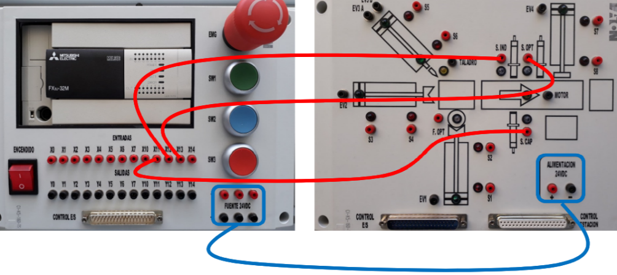

Example of Connection of the Ejection Unit

|  |  |
| --- | --- |
| INPUTS > SENSORS | OUTPUTS > ACTUATORS |
| X7 > S7 | Y4 > EV4 |
| X10 > S8 |  |

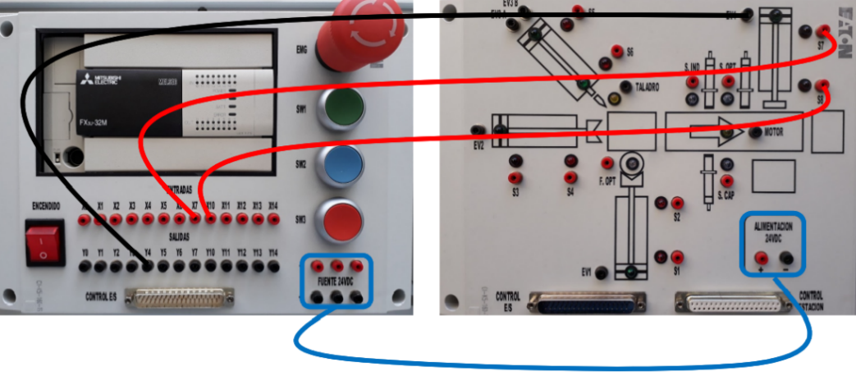

# CONNECTION CONFIGURATION THROUGH I / O CONTROL CONNECTOR

As an alternative to point-to-point connection of inputs and outputs via cables banana, you can use the 37-pin female-male flat cable and connector [I / O CONTROL] for direct communication between the PLC Control Panel and the Operation Panel with the already established configuration of input and output addresses. With this it is no longer necessary connect any banana cables for system operation.

**IMPORTANT:**

**DO NOT CONNECT THE I / O CONTROL CONNECTOR AND THE POINT-TO-POINT CONNECTION WITH BANANA CABLES TO AVOID DUPLICATION OF SIGNALS AND POSSIBLE SYSTEM MALFUNCTION**

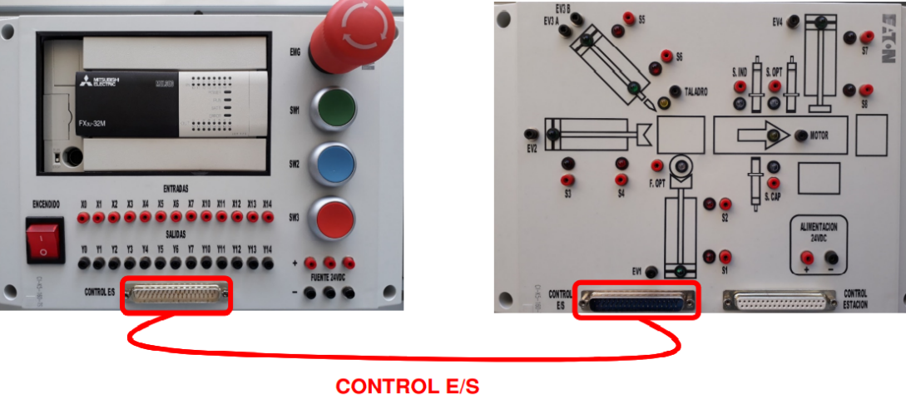

# I / O CONTROL CONNECTOR INPUT AND OUTPUT ASSIGNMENT TABLE

Input assignment table for the 37-pin [I / O CONTROL] connector

|  |  |
| --- | --- |
| PLC Inputs | Device Connected |
| X0 | Optical fiber sensor [F. OPT] |
| X1 | Feed Unit Piston Reed Sensor “Retracted” [S1] |
| X2 | Feed Unit Piston Reed Sensor “Extended” [S2] |
| X3 | Reed Sensor Charge and Transfer Unit Piston "Retracted" [S3] |
| X4 | Reed Sensor Charge and Transfer Unit Piston "Extended" [S4] |
| X5 | Reed Sensor Manufacturing Unit Piston "Retracted" [S5] |
| X6 | "Extended" Manufacturing Unit Piston reed sensor [S6] |
| X7 | Reed Sensor Eject Unit Piston "Retracted" [S7] |
| X10 | Ejection Unit Piston reed sensor “Extended” [S8] |
| X11 | Capacitive Sensor [S. CHAP] |
| X12 | Inductive sensor [S. IND] |
| X13 | Optical Sensor [S. OPT] |
| X14 | Not assigned |
| X15 | Green Button NA [SW1] |
| X16 | Blue Button NA [SW2] |
| X17 | Red NC button [SW3] |

Output assignment table for the 37-pin [I / O CONTROL] connector

|  |  |
| --- | --- |
| PLC Outputs | Device Connected |
| Y0 | Power Unit Solenoid Valve [EV1] |
| Y1 | Charge and Transfer Unit Solenoid Valve [EV2] |
| Y2 | Manufacturing Unit Solenoid Valve Position A [EV3 A] |
| Y3 | Manufacturing Unit Solenoid Valve Position B [EV3 B] |
| Y4 | Ejection Unit Solenoid Valve [EV4] |
| Y5 | Drill |
| Y6 | Conveyor Belt |
| Y7 | Not assigned |
| Y10 | Not assigned |
| Y11 | Not assigned |
| Y12 | Not assigned |
| Y13 | Not assigned |
| Y14 | Not assigned |
| Y15 | Red Signal Turret Lamp |
| Y16 | Orange Signal Turret Lamp |
| Y17 | Green Signal Turret Lamp |

# CREATING A PROGRAM

For the configuration and use of the software refer to the separate manual

* Manual GX-WORKS2\_FX3U [Mitsubishi PLC Programming Software]

# SYSTEM SHUTDOWN PROCEDURE

1. Open the shut-off valve
2. Disconnect the air line from the maintenance unit
3. Turn off the main switch of the PLC Control Panel
4. Preferably enable emergency stop in the PLC Control Panel
5. Disconnect the programming cable from the PLC Control Panel.

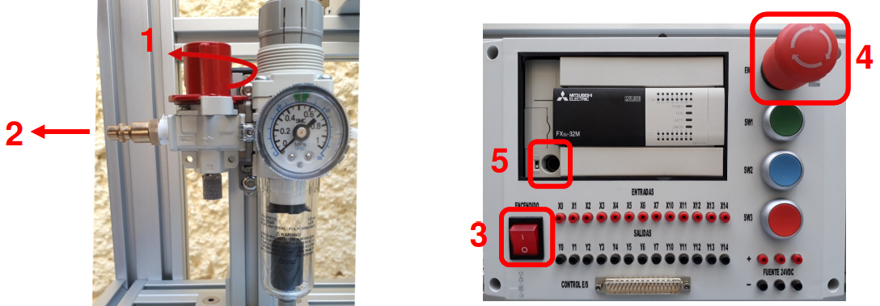

1. Disconnect the banana cables or ribbon cable between the PLC Control Panel and the Operation Panel
2. Disconnect the cables from the STATION CONTROL AND ENGINE CONTROL connectors. the Main Structure Connection Unit and the Operation and Control Panels of Band
3. Disconnect the equipment from the power supply

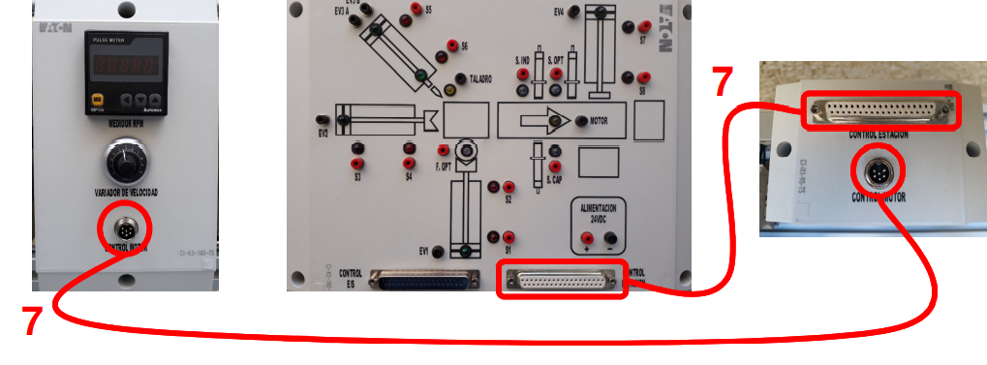

The workbench carries a set of sensors labelled as their names, SF for the Fiber Optic Sensor, SI for the Inductance Sensor, SC for the Capacitive Sensor, and SL for the Lux Sensor. It also handles a Variable Frequency Drive that supports the motor control for a band that carries the entire process, the label MT represents the coil that controls the band.

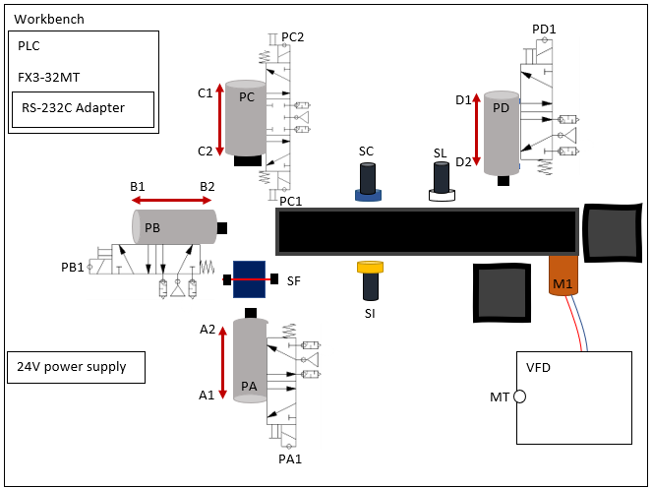

AC main voltage

First at all the system might remain in some predefined positions, according to the scheme of the system done by the organization. The cylinder A, B and D must remain contracted, but C must be extended, which means that sensors A1, B1, C1 and D1 must be enabled to start the operation, then the sensor SF must be activated to verify that the system containing a piece of material to start the manufacturing process.

Once the principal configuration is done, the user could push the green button to represent the start of the system, in that way, immediately the cyl A must be extended for staying there until Cyl C terminates its purposes, while Cyl A extended, the Cyl C must be contracted to perform the drilling, to later being extended again, when the Cyl C stays at its beginning position, Cyl A must recover to its initial state and Cyl B must be extended to move the piece to the band, then, when the Cyl B gets back to its initial state, the motor which allows the movement in the band will be turned on. Then a logical operation is done with the sensors SI and SC, if the material is plastic only one of them will be triggered, but if the material is metallic, both are going to be set up. The organization though that it could be implemented an and gate to represent the combinational logic in that section, the selection must be done and stored in a memory to remember, then in the next part is divided in two different possibilities, a plastic, or a metallic material. the sensor SL will trigger the divergence, if there is a plastic material the band will remain on until the material is allocated in its place, but if it is a metallic material, the band will stay on until a second and it will stop in a certain position to being moved by the Cyl D.

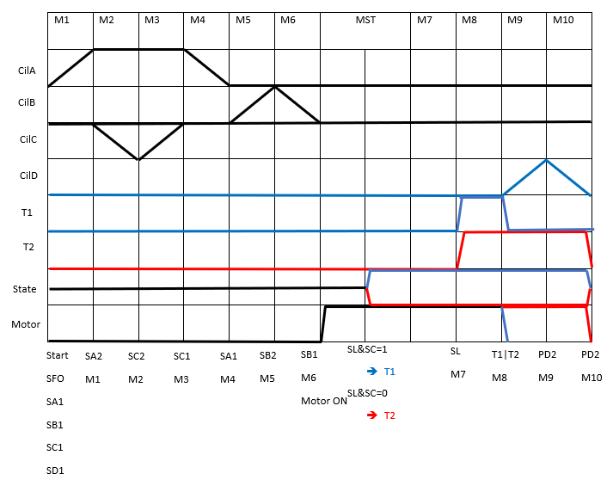

By applying the methodology, a control table was developed following the structure shown in the phase diagram.

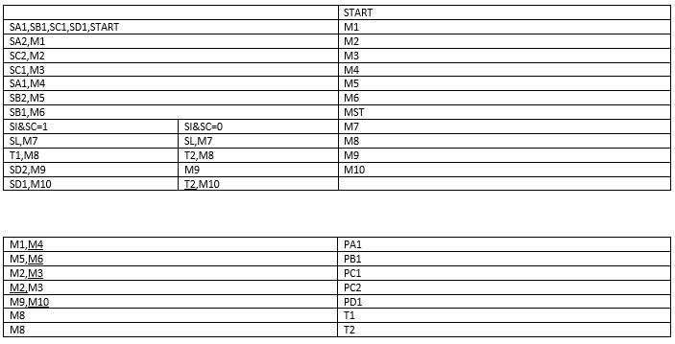

Finally, the power table was realized regarding the power appliances done in each section and memory instance.



The organization developed the ladder diagram where it was followed the instructions to operate in a simulation which determines the same functionality as the real PLC workbench. It was used fluid sim to simulate the pneumatic actuators and sensors involved in the machinery.

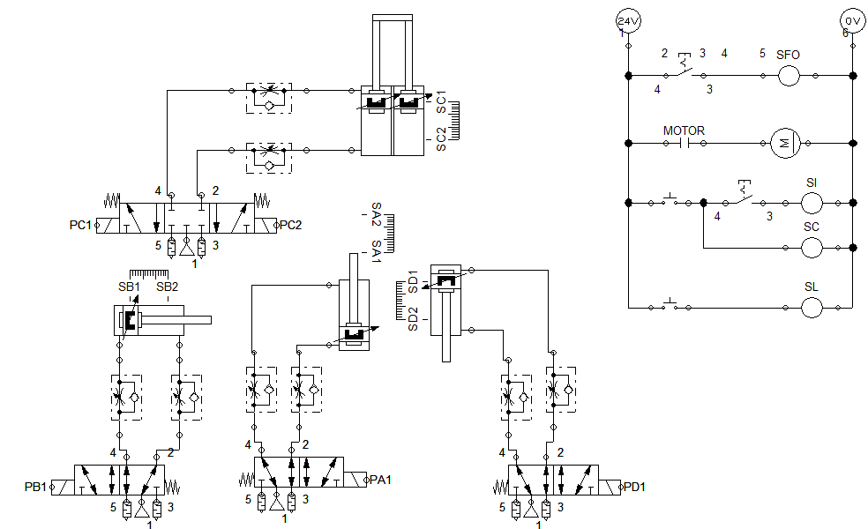

By doing that the approach may be closer to the real application in the field, the use of such development platforms eases the design and the implementation of the automation involved in the machinery without taking any risk.

The ladder diagram followed the instructions done in the power table, which served as a basis to structure the entire ladder automation to perform the required action.

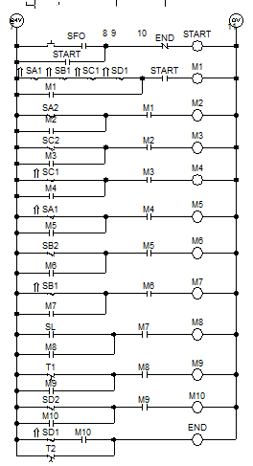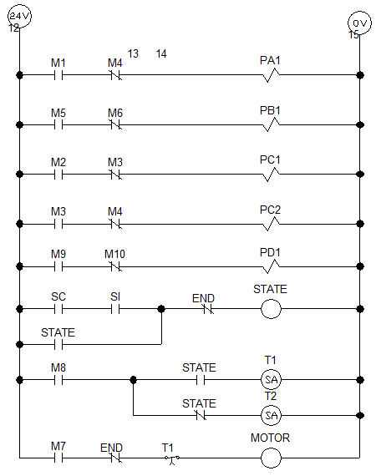

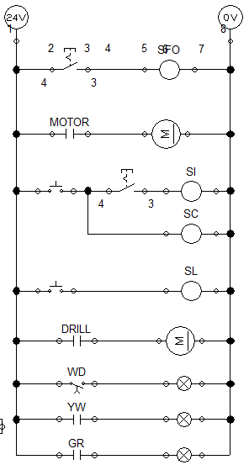The ladder diagram was adapted to represent the parameters required by the customer, a set of different timers and logic operators were implemented to follow the procedures required. The motor might stay on once the system starts, the optical fiber sensor might have a certain delay to ensure the correct timings by sourcing the material in the process, if there is a problem with the material, ies a watchdog timer will carry the watching of the process and finally the green and yellow light might follow the MW state.

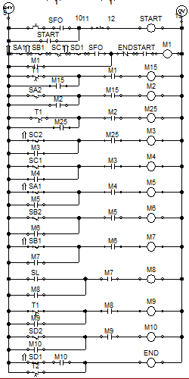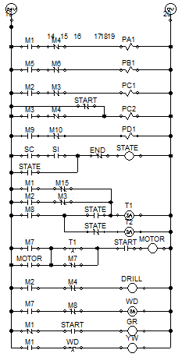

**IoT node with ESP32**

The ESP32 will handle a Deep Sleep mode to save energy while the workbench is processing nothing, the FL817 optocoupler will trigger the external wake up pin of the micro to determine when is going to be used the workbench, the CPU will last ON until the process finishes.

In the other hand the mains voltage will provide the power supply to power the entire circuit, the internal current will be measured with a current sensor and by analyzing the current consumption while on we can determine how much energy uses the circuit to work. The ESP might be sourced by a LDO regulator that handles the less power as possible.

Current sensor

ESP32

MAX3232

FL817

AC-DC HLK PM01 5VDC

3.3V LDO regulator

The resulting system perform the integration of both diagrams.

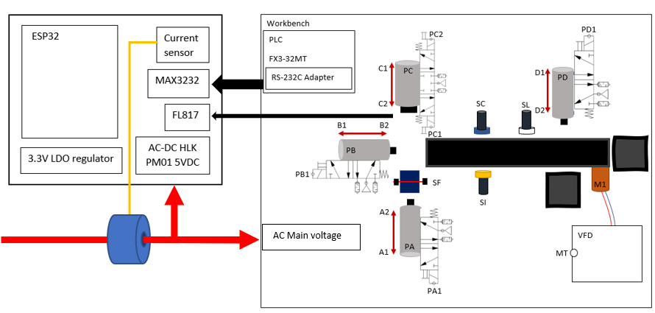

The PCB must include the 3.3V low power regulators for sourcing the different components for the PCB, the MCP1700 LDO achieved the best approach to the problem. In the other hand the customer gave to the organization different options to vary from different power sources, that’s why the organization decided to include its own DC power supply board which carries an HLK-PM01 required to provide a stable 0.6A 5V power source.

The organization considered to include the RS232 to TTL module to simplify the manufacturing process of the physical connection between machine to machine.

The power module might be composed by a single DC power supply attached to the mains voltage, by implementing a set of predefined components we can ensure the noise and EMI interreference dissipation for stablish a stable power line.

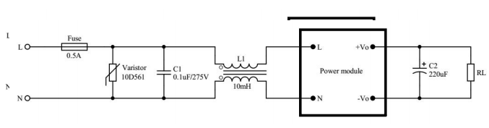

Slow blow 0.5A Fuse used to protect the circuit from damage when the module is abnormal.

10D561 Metal Oxide Varistor used to protect the electronic devices against overvoltage.

0.1uF/275Vac safety capacitor that provide filtering safety protection by an EMC certification.

10mH Choke mode Inductor that carries EMI filtering over 70 to 500 mA.

The MCP1700 is a low drop out regulator that handles a 1.6 μA Typical Quiescent Current, which is suitable for ultra-low power devices.

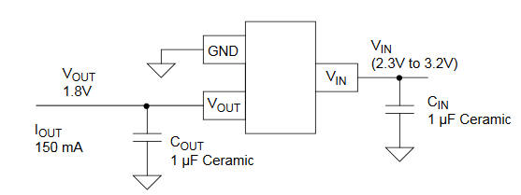

The maximum current is 250mA, that’s why the organization stated that two regulators might be useful due normally the ESP32 could achieve a 240mA current consumption peaks that might be critical for the regulators if its normally shared.

In the other hand, the ESP32 must have the minimum circuit to operate properly without any intervention of other device that does not follow the main idea in this project. That’s why the organization recreated its own development board to handle the proper dimensions and connections for the minimum circuit of the ESP32, to being connected to the different modules and regulators to perform the functionality.

The SCT-013 current sensor might include the ADS1115 ADC + PGA board that carries the measurement of the differential voltage of the current sensor when is powered.

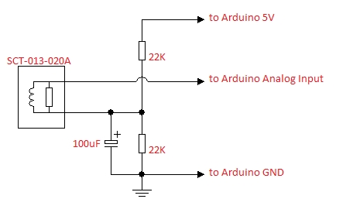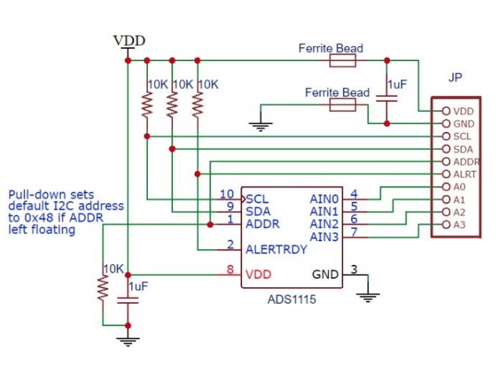

A1

A0

In the other hand, the RS232 to TTL converter was obtained by a development board that might ease the speed of the project, the scheme involved in the board follows the same basic idea to transform RS232 signals to TTL levels that could handle the microcontroller, in this case into 3.3v levels using the MAX3232 module.

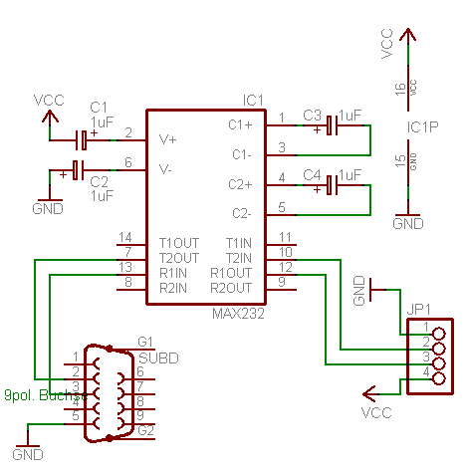

The system includes an optocoupler to interface a single digital pin from the PLC to the ESP32, which might serve to enable the ESP32 from the deep sleep mode that may ensure the ultra-low power consumption.

All the boards must be interconnected in the same boards that’s why the organization might design a board that could carry the connection of all the different components required for this project.

The power source diagram of the PCB might be left as:

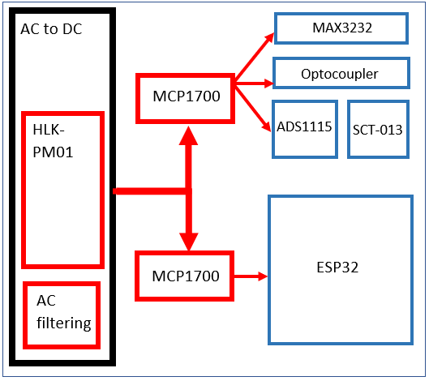

And the functional diagram of the PCB as:

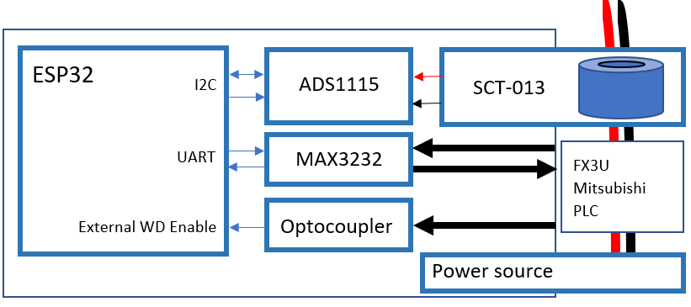

According to the defined functional and power source diagrams, the schematics could be designed to follow the requirements shown previously, the organization gathered all the required components according to the diagrams.

The main schematics might include the required components which composes the boards in the PCB, those components are found according to the datasheets as discussed previously.

The board will be composed by a set of different boards that will interconnect the system into a multiboard system.

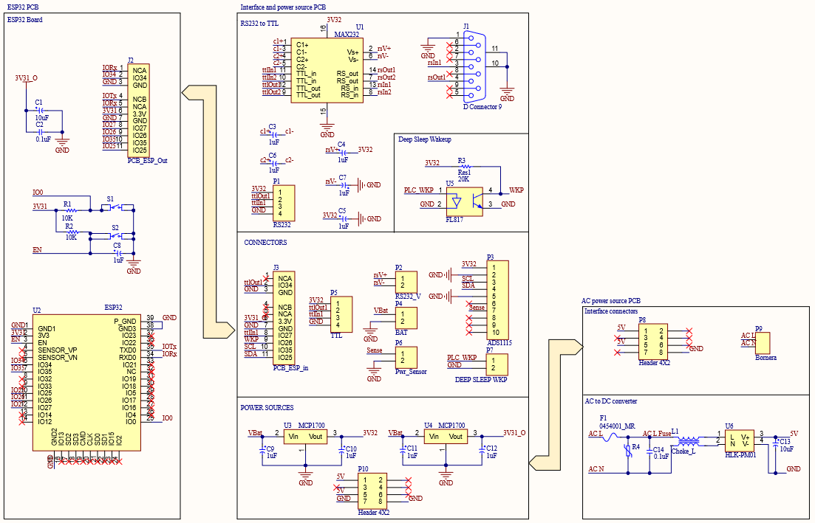

The ADS1115 was obtained in a predefined board as well as the RS232 module, that might be considered as a 10-pin header that interfaces the ADC + PGA with the different sensors with the microcontroller by implementing an I2C communication and a 4-pin header that provides a RS232 to TTL conversion.

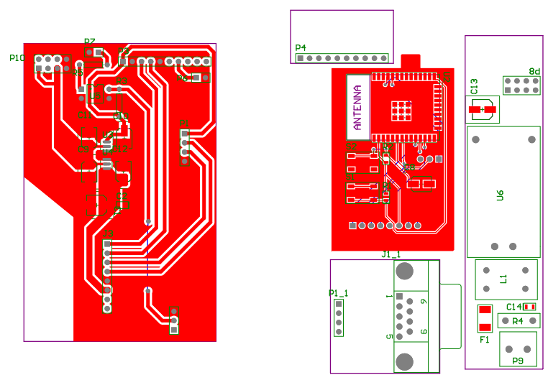

The power source board was designed previously by the organization, and it carries the components described above, it handles the 4x2 connector and it ensures the proper handling of an AC source, it isolates all high voltage signals and ensures the safety to the customer and to the organization as well.



The ESP32 is used in the board provided by the organization, it was easy to implement due the organization had designed the ESP’s minimum circuit boards previously. Also, by recycling the PCB, the organization can help the environment in some way and providing a fast solution to the customer.



The entire system might be interconnected by the mains board, that handles the connectors to interconnect the different components and will provide the power source to every section according to the power source and functional diagrams.



All boards might be allocated in the top side of the mains board. It will carry the enough isolation to provide a clean source with the different connectors and might compose the entire system as a single board which handles different modules.

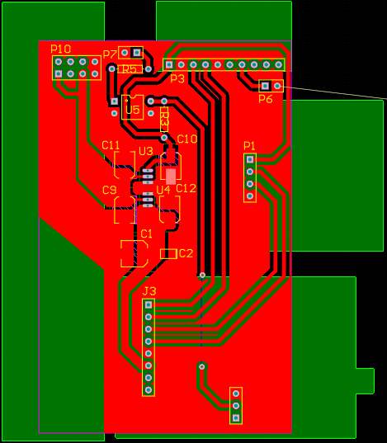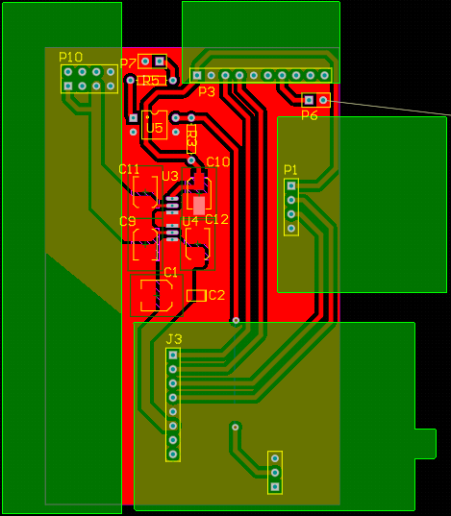

**Software**

The diagram flowchart shows the development that the organization took to execute the process by using an ESP32 microcontroller.

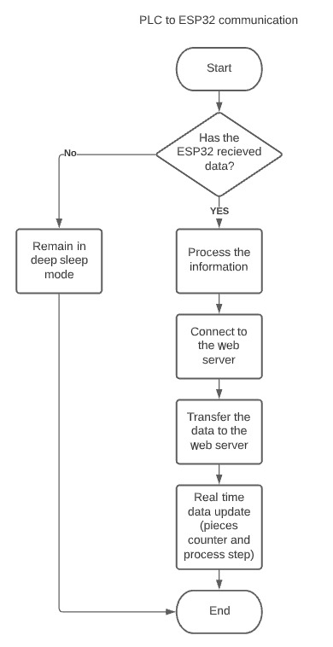

Image 4.PLC to ESP32 communication flow diagram

The graph show the basic structure, the module will remain in deep sleep mode until it receives a trigger from the PLC, if it does, the data processing determines the entire process to gather all the data that the PLC send through the RS232 module and the signal processing to obtain the power consumption, the module will get connected to the network and will publish the data into the MQTT topics to falling asleep at the end.

Deep sleep mode

The following section will be devoted to providing an in-depth understanding of the sleep mode, its advantages, the functions necessary for its optimal operation, among other relevant information.

ESP32 is capable of light sleep and deep sleep power saving modes.

In light sleep mode, digital peripherals, most of the RAM, and CPUs are clock-gated, and supply voltage is reduced. Upon exit from light sleep, peripherals and CPUs resume operation, their internal state is preserved.

In deep sleep mode, CPUs, most of the RAM, and all the digital peripherals which are clocked from APB\_CLK are powered off. The only parts of the chip which can still be powered on are:

* RTC controller
* RTC peripherals
* ULP coprocessor
* RTC fast memory
* RTC slow memory

WiFi/BT and sleep modes

In deep sleep and light sleep modes, wireless peripherals are powered down. Before entering deep sleep or light sleep modes, applications must disable WiFi and BT using appropriate calls

([esp\_bluedroid\_disable()](https://docs.espressif.com/projects/esp-idf/en/latest/esp32/api-reference/bluetooth/esp_bt_main.html" \l "_CPPv421esp_bluedroid_disablev), [esp\_bt\_controller\_disable()](https://docs.espressif.com/projects/esp-idf/en/latest/esp32/api-reference/bluetooth/controller_vhci.html#_CPPv425esp_bt_controller_disablev), [esp\_wifi\_stop()](https://docs.espressif.com/projects/esp-idf/en/latest/esp32/api-reference/network/esp_wifi.html#_CPPv413esp_wifi_stopv))

WiFi and BT connections will not be maintained in deep sleep or light sleep, even if these functions are not called.

Entering deep sleep

[esp\_deep\_sleep\_start()](https://docs.espressif.com/projects/esp-idf/en/latest/esp32/api-reference/system/sleep_modes.html#_CPPv420esp_deep_sleep_startv) function can be used to enter deep sleep once wakeup sources are configured. It is also possible to go into deep sleep with no wakeup sources configured, in this case the chip will be in deep sleep mode indefinitely, until external reset is applied.

External wakeup (ext0)

RTC IO module contains logic to trigger wakeup when one of RTC GPIOs is set to a predefined logic level. RTC IO is part of RTC peripherals power domain, so RTC peripherals will be kept powered on during deep sleep if this wakeup source is requested.

Because RTC IO module is enabled in this mode, internal pullup or pulldown resistors can also be used. They need to be configured by the application using [rtc\_gpio\_pullup\_en()](https://docs.espressif.com/projects/esp-idf/en/latest/esp32/api-reference/peripherals/gpio.html#_CPPv418rtc_gpio_pullup_en10gpio_num_t) and [rtc\_gpio\_pulldown\_en()](https://docs.espressif.com/projects/esp-idf/en/latest/esp32/api-reference/peripherals/gpio.html#_CPPv420rtc_gpio_pulldown_en10gpio_num_t) functions, before calling esp\_sleep\_start().

In revisions 0 and 1 of the ESP32, this wakeup source is incompatible with ULP and touch wakeup sources.

[esp\_sleep\_enable\_ext0\_wakeup()](https://docs.espressif.com/projects/esp-idf/en/latest/esp32/api-reference/system/sleep_modes.html#_CPPv428esp_sleep_enable_ext0_wakeup10gpio_num_ti) function can be used to enable this wakeup source.

Network communication

IoT platforms provide multiple benefits to companies in the industrial environment: from boosting automation and productivity to generating new management models. However, without network protocols, these systems could not be implemented.

In other words, IoT protocols are to machine-to-machine communication what languages, gestures, or body language are to human-to-human communication. So, just as two humans need to speak the same language in order to understand each other, devices need to use the same IoT protocols to exchange information.

For their operation, the emerging data protocols used in IoT networks have several levels:

* Application: the interface between user and device.
* Network: it enhances the communication between the router and each of the devices connected to the network.
* Transport: facilitates data communication between the different levels and ensures its security.
* Physical: the physical communication network between devices.
* Data link: responsible for transporting data in the system and detecting and correcting problems.

In IoT device communication with the Internet, the most common protocols are MQTT, CoAP and HTTP. They are highly flexible as they are designed to transmit any type of information.

In this case, the MQTT (MQ Telemetry Transport) protocol will be used. It follows a publish-subscribe model, allowing communication between many devices. For its operation, a central server called broker oversees receiving the messages from the transmitting devices and distributing them to the receivers. The messages are also organized hierarchically by tags.

The central server called broker is linked to the MyQTTHub platform, which is responsible for receiving messages from the sending devices and distribute them to the receivers, in this case would be to receive the variables of the actuators that make up the PLC, the amount of metal parts, plastic and current consumed by the machinery in real time.

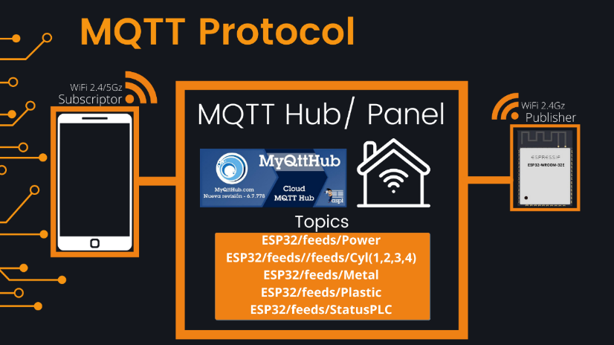

Image 1. Description of communication protocol

RS232 to UART

The RS-232 protocol is an asynchronous serial communication protocol, it does not have an order in which data is sent between devices. that is, it does not have a data sending order between devices, so it is necessary to take care of the synchronization of the therefore it is necessary to take care of the synchronization of the sending to avoid loss of information or communication failures. information or failures in the communication.

Another of its main characteristics is that it is a point-to-point protocol, that is, it only allows communication from one device to another using a communication terminal. to another using a specific communication terminal. It does not allow the creation of networks.

It is a protocol developed for serial communication of single devices, widely used due to the ease of communication and cost advantages of serial communication. It makes use of DB-25 type connectors; however, it is common to observe devices with DB-9, 9-pin connectors due to their lower cost.

The electrical interface uses an asymmetrical electrical connection with unbalanced circuits, all referenced to ground. The logic states are defined by the following voltage levels:

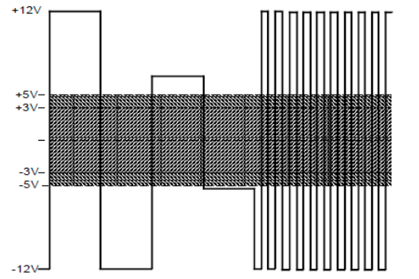

Image 2. RS-232 circuit voltage specifications.

As can be seen, the standard considers a logic one to any voltage value between -5 and -12 volts, and a logic zero to those values between 5 and 12 volts positive, with a transition zone (forbidden operation zone) from 5 to -5 volts.

The interface is used at a rate of less than 20Kbps for less than 15m. In practice, these limits can be exceeded by using low-capacity cables in electrically low-noise environments.

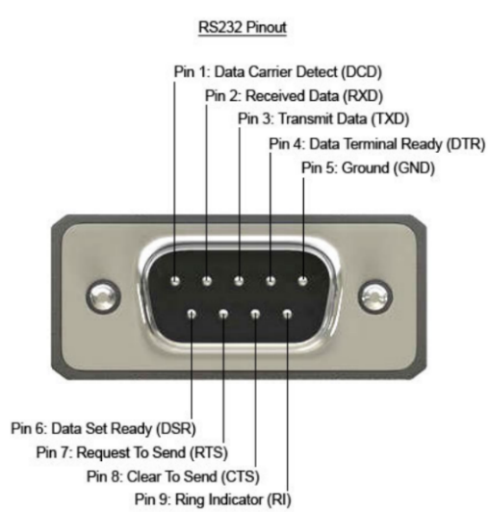

Image 3. RS-232 circuit connector with indication of each of its meanings.

The data sent over RS232 lines is simply positive (+) and negative (-) voltage pulses relative to a ground reference. A group of +/- pulses sent by a device are carefully timed by the receiving device and decoded into what the hardware settings consider data bit packets. In other words, the RS-232 standard only defines a relatively flexible general electrical framework for transmitting and receiving electrical pulses. What one does with all these pulses ultimately depends on the connected hardware. Things like character encoding, spacing, start bits, stop bits, bit order, error detection, bit rate, etc. are not the responsibility of the RS-232 scope and are set by the user's connected circuitry, usually in the form of a serial communication port and its associated chips and transistors.

The job of the COM port is to make sense of the pulses on behalf of the connected computer or peripheral. For reference, an RS-232 system must transmit from one device (sending on its Tx pin) to a receiving device (receiving on its Rx pin) and vice versa. Do not try to connect Tx to Tx or Rx to Rx in a three-wire RS-232 system! The only pin that is directly connected is the ground connector, which gives both ends a common reference point for measuring pulses. Each RS-232 controller uses inversion logic and employs a single terminal, bipolar output voltage to feed a UART (Universal Asynchronous Receiver/Transmitter). Because the system has three wires and two separate communication channels, it is considered a "Full Duplex" system. Data can be transmitted at the same time as it is received.

Data readout

- The first step of the data reading process starts with a check to evaluate if the ESP is connected and ready to receive information, if the buffer remains empty, the ESP will go to deep sleep state to avoid significant power consumption. Otherwise, if the buffer is correctly fulfilled by the proper header command “$”, the ESP will continue the process.

- The second step is fundamental, is where the translation of the data obtained is done, for example, each PLC actuator used will be considered as a variable that will be sent in a string of information which will be translated and presented on the Web server to facilitate the visualization of the data.

Each actuator, sensor and component that transmits an important data is represented by a variable, in this case it is represented by variables that are represented from 1-7 respectively, this string of data will be sent by the PLC to the RS232, which will translate the information and with the help of the ESP can interface to the web server, obtaining the data in real time.

* Actuator 1 :Start-up
* Actuator 2: Drill
* Actuator 3: Secondary displacer
* Actuator 4: thirdth displacer
* Metal: Metal products
* Plastic: Plastic products
* PLC Status: Current state of PLC

The data is transferred in registers to represent big numbers with two bytes, so it was implemented a set of bitwise operators to obtain the data from the message obtained.

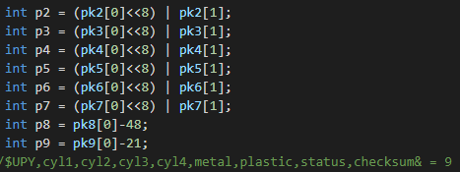

Power consumption

The power consumption is carried out by the noninvasive current sensor, which is attached to the ADS1115, it is better known as a twelve-bit Analog to Digital Converter, it is integrated with a Programable Gain Amplifier which is helpful to acquire very low signals. It is normally set to a gain of four that may ensure the proper measurement of the low voltage generated by the current sensor.

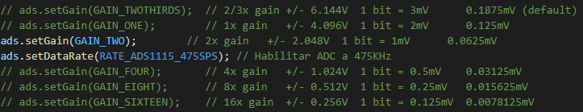

Also, the usage of a sample rate of 475 samples per second provide us a very precise deterministic measurement for a 60 Hz signal according to the Nyquist theorem.

The current sensor is the SCT-013 noninvasive current sensor that it has a fixed factor of 100A over 50mA. The fact that our current sensor is a coil that produces a proportional current brings the possibility to introduce a very precise resistor to obtain a voltage output from the sensor. The usage of a 22 ohms resistor ensures a 1.1 Vp as a maximum peak voltage from the 50mA maximum output current from the sinusoidal wave of 60Hz acquired by the sensor. The calculations may vary from the accuracy of the resistor used but the sensor might remain as 100A over 1.1V.

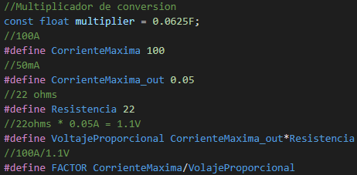

The equation to measure the current is the famous root mean squared that provides the Irms function in a deterministic way, the raw value will be measured by the differential of both terminals which is attached the sensor and will be multiplied by the constant multiplier of the PGA factor, then the millivolts are converted into voltage to being finally converted into current, which will be powered by two and being added into the summatory that represents the function, every cycle will be repeated in one second, the enough time to realize 475 samples according to the sample rate of the ADC.

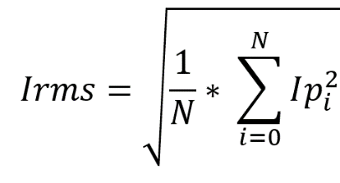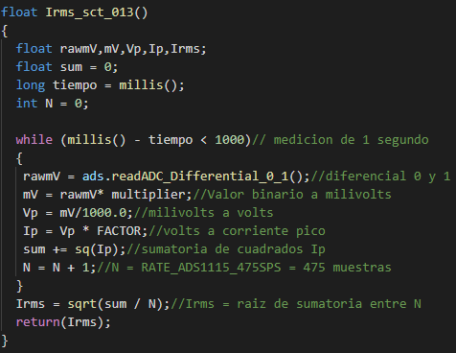

The final power consumption is measured by analyzing the total power according to the power equation Irms by Vrms is equal to the power in Watts, which can be represented as Joules per second.

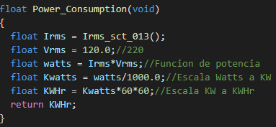

The power is converted from watts to kilowatts, to finally represent the total consumption in an hour, which is finally represented as Kilowatts per hour.

Server Connection

-The next step is to verify the Internet connection to be able to have connection with the Web server, it is necessary to guarantee the network quality and verify that the server does not present any technical problem, that’s why MyQTTHub was one of the best options, due the flexibility and it is o pen source.

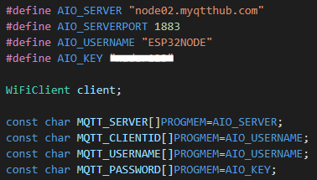

- Once connected to the server it is time to transfer the data to the server, once the PLC collects the necessary data it sends the information through the RS232 protocol, so that later it can be translated the information collected through variables as mentioned above which will be presented in the UART as $$UPY,XX,XX,XX,XX,XX,XX,X,29$$& and then that information will be sent to the Adafruit server through the MQTT protocol where the decoded information will be observed through graphs and counters in real time according to the different topics in the MQTT broker.

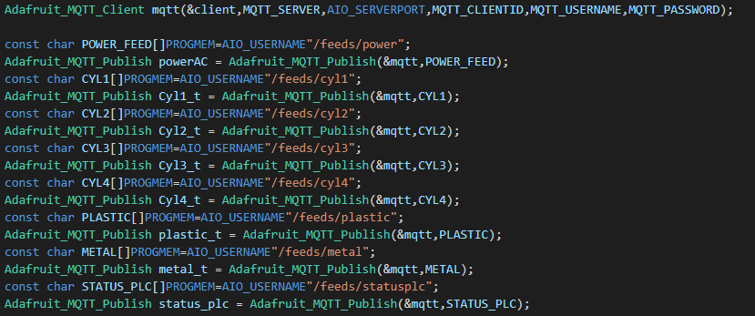

Real time data update

-Finally, the information and updates will be presented in real time, so that users have the information about their production process whenever they require it, in this way they can make sales projections, as well as predictions to make changes in machinery or raw material for their optimal production process, and to make changes in the production process.

